**AUTHOR NAME - Gursewak Singh**

**STUDENT ID – 100383511**

**Title - Final Project**

**COURSE NUMBER – INFO1113 S11**

**INSTRUCTOR NAME – Dr Abhijit Sen**

**DATE - NOV 26 2019**

**WEBSITE URL (Gursewak singh) –** [**https://sites.google.com/view/unknown1/my-personal-profile**](https://www.google.com/url?q=https%3A%2F%2Fsites.google.com%2Fview%2Funknown1%2Fmy-personal-profile&sa=D&sntz=1&usg=AFQjCNGUTuhjIvAN_cyoYpq4eHmlXR5vuQ)

**TEAM MEMBER NAME – NAVJOT KAUR**

**STUDENT ID - 100385217**

**WEBSITE URL(TEAM MEMBER) - https://sites.google.com/view/navjotkaursite/home**

**GIT HUB URL(TEAM MEMBER) - https://github.com/Navjot1428/FINALPROJECT.git**

**All the contents mentioned below are done by me (Gursewak)**

# **Executive summary: (First paragraph)**

Daily fitness is a community-based health and fitness mobile application aiming to curb the rising trend in obesity levels and increase physical activity as well as proper diet by tapping into huge markets of the penetration of smartphone devices. This application offers an endless supply of balanced diet and fitness advice through user-generated contents moreover, a community where users can advise and aid each other with their health and fitness goals.

# **Introduction: (Full)**

As the main goal of this website is to help people to improve health by using daily diary products, meat, and by doing various exercises such yoga and meditation. In this Project we (Gursewak & Navjot) have discussed all the project requirements that are essential. We have started the project from listing some of the Functional and Non-Functional requirements with some explanation. However it was not possible to move into further details without giving the information about our website, so to do this we have made a Use case Diagram with two descriptions also a class diagram is created on the basis of use case diagram. Moreover the use case description of login has been taken further and sequence diagram is drawn.

Furthermore in this project we have also shown the prototypes that will be used by the users in these prototypes we have shown that how a screen will look like on mobile as it is a mobile application only so we have not shown the prototypes for laptop or tablet screen. After this we have used the class diagram to create a database in access with some different type of queries. While doing this project some things were easy whereas some were difficult so there is also one paragraph for the project experience. In the last second paragraph there is a summary for this introduction along with this the last paragraph is dedicated to all the texts that are referred in this whole report.

# **Project Requirements *(Functional requirements are written by me and non-functional are written by navjot)***

**Functional Requirements**

**(A) User Data**

A user’s email address will need to be stored in order to give each user an alias to operate the application under. The email address will be used for account validation and to tie a user to their contents.

A user needs to create a password in order to verify themselves when accessing the system. The password will need to be stored in the system and tied to user’s email address.

**(B) Login**

The system should provide a user friendly **Graphic User Interface** to allow the user to login when the application launches.

The system should prompt the user for their email address and password.

*The system should provide notification if the submitted data is incorrect.*

**(c) Submit a key index**

The body mass index provide intuitive **User Interface** for logged in users to allow them to submit their current health status to the application.

*The system should prevent the users from submitting invalid height and weight.*

The system shall takes the successfully submitted data for further functions of application to work.

**(D) View Existing Programs**

The system should provide intuitive and user friendly navigation to allow users to locate the current list of diet plans as well as exercises and choose the best match.

The system shall display the full details of the diet and exercise routine once one is selected by the user.

The system should allow quick and easy navigation between different diets as well as routines in the list.

**(E) Rate a Program**

The system should provide an option to rate a program. The user can rate a program on the basis of benefits and problems the user faced while using the program.

Program will be displayed on the basis of ratings. High rated program will be displayed on the top however low rated program will be displayed on the bottom of the list.

**Use Case Diagram and description *(* *Final Use case diagram was drawn together so I am not uploading it)***

**Use Case Description:**

**Originator name: - Gursewak Singh**

|  |
| --- |
| Use case title: Log In |
| Primary Actor: Anyone with the internet access and who want the healthy lifestyle can be a user. |
| Goal : Log in to access the features of the website |
| Level: Kite level |
| Preconditions: Interconnection is foremost condition. |
| Minimal Guarantee: The user will logged into Website when the username and password is entered correctly |
| Success Guarantee: The user can successfully access the website and perform actions appropriate for his or her role. |
| Trigger: User access the website homepage. |
| Main success scenario:  1.a The user enters the Username and password to get access to the website features.  1.b The system validate the entered username and password and if the validation takes place successfully user gets the access to website features.  1.c If the user do not remembers the password the user click on the reset password. |
| Extensions:  1a. The website determines that the password is incorrect  1a1. The website displays the error message on screen (The password you entered is incorrect).    1b. The user do not remembers the password and clicked on the reset password.  1b1. The user verify that the account belongs to him and resets the password.  1b2. The user failed to verify that the account belongs to him and didn’t get access to the website. |

**Reviewer name:- Navjot kaur**

As the **Use case title** illustrates this is the use case description on log in in which the **Primary Actor** could be anyone with the internet access and logged in to website can be a user. Moving ahead the **Goal** is to Log in to access the features of the website. This use case description is on the Kite **level** and the only **Precondition** is that the Interconnection is foremost condition. The **Minimal Guarantee** that the user will logged into Website when the username and password is entered correctly and the **Success Guarantee**  is The user can successfully access the website and perform actions appropriate for his or her role.

However **Main success scenario** is that the user enters the Username and password to get access to the website features and if the system validate the entered username and password and if the validation takes place successfully user gets the access to website features. However If the user do not remembers the password the user click on the reset password. **Extensions** is that if the website determines that the password is incorrect then the website will displays the error message on screen (The password you entered is incorrect). Moreover the user may do not remembers the password and clicked on the reset password. However if the user may verify that the account belongs to him and resets the password also it is possible that the user failed to verify that the account belongs to him and didn’t get access to the website.

# **Interface Prototypes: *(These prototypes are drawn by me and the remaining by navjot)***

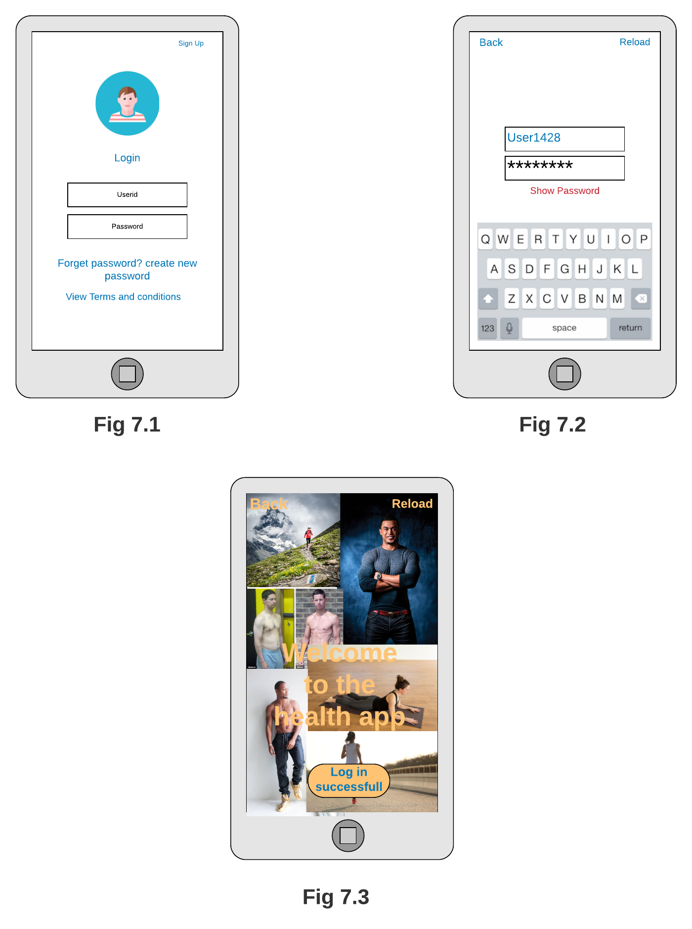

**Fig 7.1 As shown in the login screen with login screen the app will look like this when the app opens. Also there is sign up button on top which user can use to create a new account and below the password box there are two options if the user do not remember the password he/she can click on reset password button and to know about terms of the app the user can click on terms and conditions of the application.**

**Fig 7.2 When the user clicks on the Userid box or password the keypad appears and then the user types the userid and password. Also there is back button and reload button on top back button can be used by user to go to the previous screen however, reload button can be used to reload the page if the page is not loaded successfully in first attempt.**

**Fig 7.3 When the entered userid and password is correct the welcome message appears with message showing the log in is successful.Also there is back button and reload button on top back button can be used by user to go to the previous screen however, reload button can be used to reload the page if the page is not loaded successfully in first attempt.**

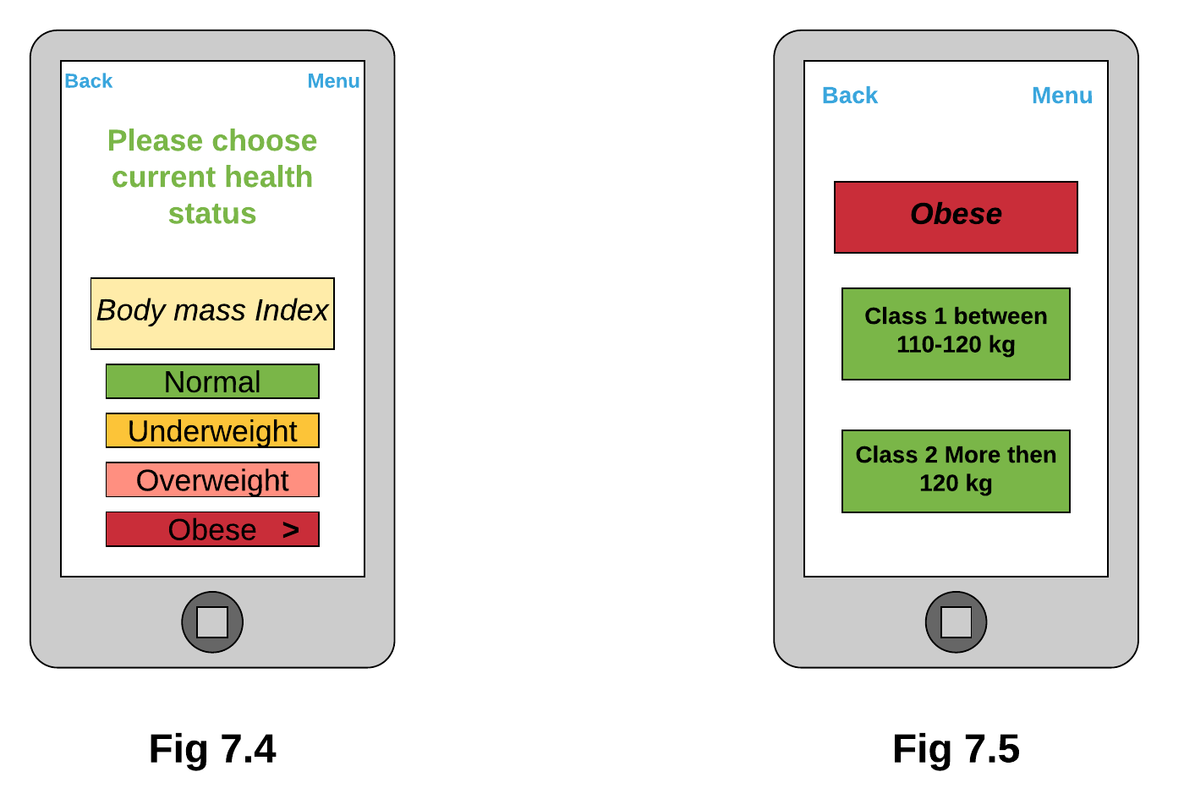

**Fig 7.4 After the login the user have to select the current health status from the given options. *Also there is back button and menu button on top back button can be used by user to go to the previous screen however, what will happen when user clicks on menu button is shown in Fig 7.10.***

**Fig 7.5 After the user clicks on the obese icon there will be new menu in which User have to choose weather he/she belongs to class one or class 2. *Also there is back button and menu button on top back button can be used by user to go to the previous screen however, what will happen when user clicks on menu button is shown in Fig 7.10 .***

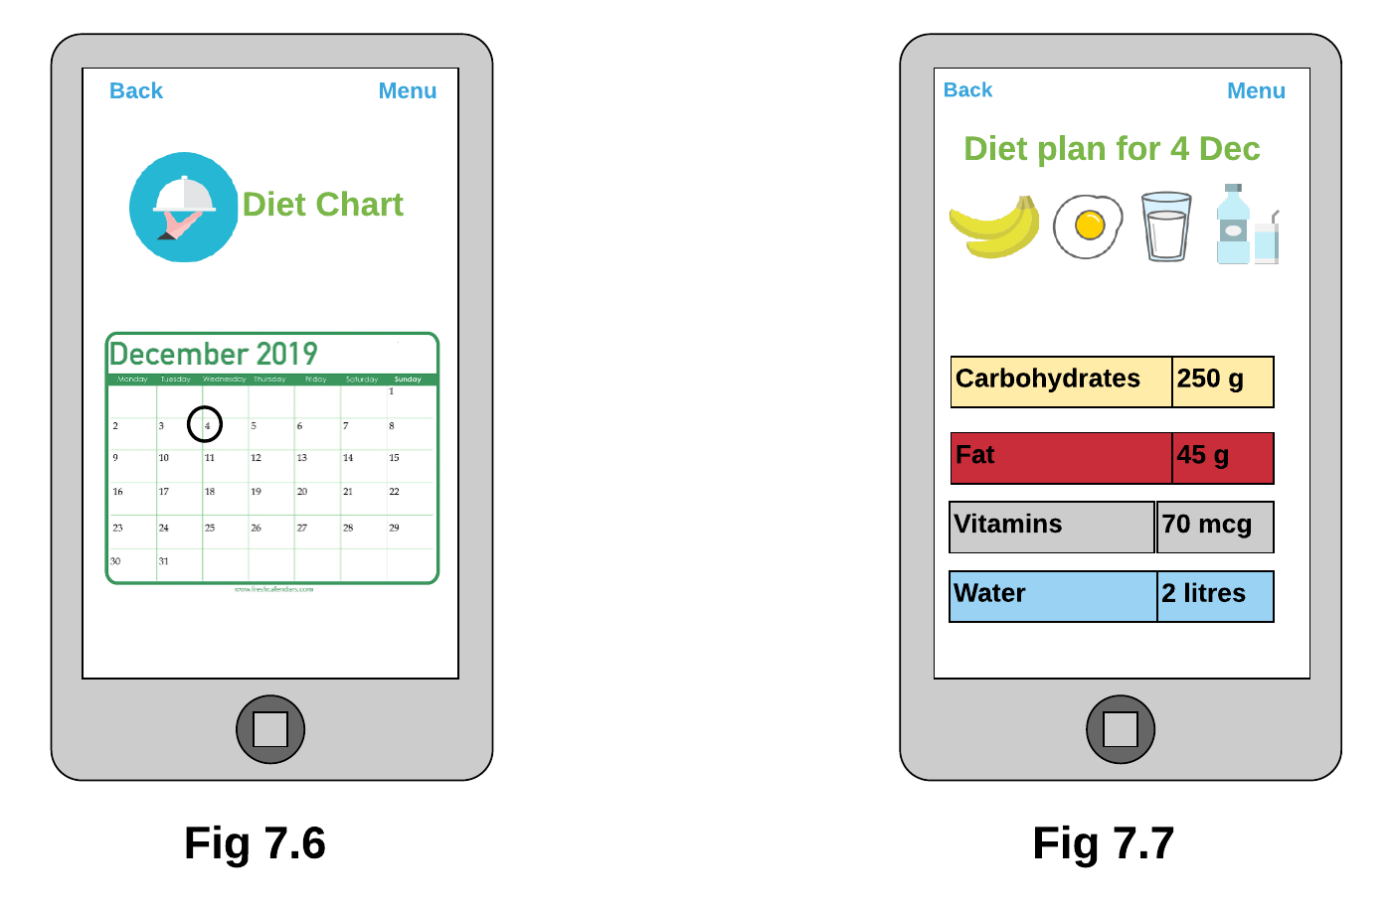

**Fig 7.6 When the user choose the class level Diet chart window will appear in which there will be diet plan for full month and the user can click on any date and then he/she can access the diet plan for the specific date. *Also there is back button and menu button on top back button can be used by user to go to the previous screen however, what will happen when user clicks on menu button is shown in Fig 7.10*.**

**Fig 7.7 Suppose the user clicks on the 4 Dec then the amount of carbohydrates , Fat, Vitamins and water the user have to eat and drink each day appears on the screen. *Also there is back button and menu button on top back button can be used by user to go to the previous screen however, what will happen when user clicks on menu button is shown in Fig 7.10 .***

# **Relational database tables: *( Relational tables are created by me and the queries by navjot so I am not uploading queries)***

1. **Relational database tables:**

**Userid is the primary key in first table :-**

|  | | | | | | | | | | | | |
| --- | --- | --- | --- | --- | --- | --- | --- | --- | --- | --- | --- | --- |
| **Userid** | **UserName** | **Height** | **Weight** | **Diet** | **Carbohydrates** | **Fat** | **Vitamins** | **Water** | **ExerciseTips** | **Time** | **Rate** |
| User111 | Gursewak | 182 | 60 | Vegetarian | 250 | 45 | 70 | 2 | Yoga | 60 | Positive |
| User222 | Navjot | 167 | 55 | Non-Vegetarian | 290 | 46 | 80 | 3 | Asanas | 30 | Positive |
| User333 | Joban | 188 | 47 | Vegetarian | 250 | 45 | 70 | 2 | Meditation | 45 | Negative |
| User444 | Hasan | 187 | 77 | Non-Vegetarian | 290 | 46 | 80 | 3 | Meditation | 45 | Negative |
| User555 | Harman | 158 | 65 | Vegetarian | 250 | 45 | 70 | 2 | Yoga | 60 | Positive |
| User666 | Aman | 144 | 60 | Vegetarian | 250 | 45 | 70 | 2 | Asanas | 30 | Positive |

**Diet is the primary key in second table :-**

|  | | | | |
| --- | --- | --- | --- | --- |
| **Diet** | **Carbohydrates** | **Fat** | **Vitamins** | **Water** |
| Non-Vegetarian | 290 | 46 | 80 | 3 |
| Vegetarian | 250 | 45 | 70 | 2 |

**ExerciseTips is the primary key in the table:-**

|  | |
| --- | --- |
| **ExerciseTips** | **Time** |
| Asanas | 30 |
| Meditation | 45 |
| Yoga | 60 |

**Project Experience: *(My experience)***

Navjot was creating the relational database tables she was taking long to create tables but then I helped her in making some adequate queries and some tables and with each other’s help everything goes well. .

Overall, it was a good experience both of us and we learned a lot from each other.